(Approx. 1,521 words)

NOOK Q & A
By Mary Phillips, member, ICON (Interactive Computer Owners Network), MO
January 2012 issue, The ICON
www.iconusersgroup.org
mphillip1 (at) sbcglobal.net

Q1.What can and can’t I do with my new Simple Touch Nook eReader? It has Wi-Fi connection.

A1. The Simple Touch Nook is a dedicated eReader. You can read books that are available from a variety of sources and you can read newspapers and magazines if you have subscriptions.

With the Nook Friends feature you can send emails to share comments and recommendations and lend/borrow some books from each other.

You can access Barnes and Noble‘s bookstore via the Wi-Fi. Word meanings can be looked up and passages can be highlighted and bookmarks can be made.

You cannot play games or music as can be done with the Color Nook or the Nook Tablet.

Q2. Where can I get Help with my Nook features?

A2. On your computer, go to bn.com and click on the tab. Under Nook Simple Touch (or other Nook device if you have a different one), select Support. There are four video tutorials, a section of Frequently Asked Questions, a Chat with a Nook Expert Chat Now
button, and the User Guides and Manuals that are also on your Nook when you get it,
but it is much easier to search for information and read IT on the computer.

Barnes and Noble help can also be reached by phone M-F 7 a.m.-10 p.m. and weekends 8 a.m. to 10 p.m. by calling 800-843-2665. I‘ve had two chat sessions and both “Experts” were very helpful. Also, the Barnes and Noble book store folks have
been very knowledgeable and helpful.

Q3. How do I get books loaded onto my Nook from Barnes & Noble?

A3. Books can be purchased from B&N by pressing the Quick Nav button at the bottom of the Nook and tapping Shop on the Quick Nav Menu Bar that appears across the bottom of the screen.

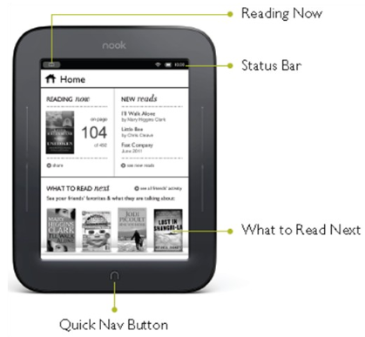

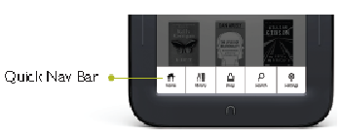

If you want to look for free ($0.00) books, tap the Search Shop button in the upper right corner. The next screen has a keyboard and search bar into which you type either the title or author of the book or the price and then tap the Search button in the lower right corner of the keyboard.

Scroll through the titles by either sweeping a finger up or down on the screen or tapping the up and down arrow points at the bottom of the page.

If you know a title you‘re looking for or to see an overview, tap on the cover picture. If it‘s a free book, tap on the Free button, then Confirm and the book is immediately downloaded directly to the Nook. If the book has a more significant price, click on the Buy button and follow the instructions; it will be downloaded to the Nook. This has to be
done where you have a Wi-Fi connection.

Q4. I’ve heard that on Fridays, Barnes & Noble offers a free eBook to be downloaded. How do I find it?

- Go to bn.com and type in the Search bar ― “Free Fridays” (without the quote marks). This will take you to B&N Community, the NOOK Blog and the free book will be listed there.
- You can also type or copy the address below in the browser address bar:
http://bookclubs.barnesandnoble.com/t5/TheNOOK-Blog/bg-p/Unbound.

To get the Free Friday book, it‘s necessary to download the book to the computer and then transfer it to the Nook. Do the following:

- Click on the title of the book. The link is in blue text and when the mouse pointer is hovered over it, the pointer changes to a hand with a pointing finger.
- The link takes you to an overview of the book and a Download Now button. If you think you want to read the book, click on the Download Now button.
- Navigate to the folder where you want the eBook to be saved and click Save.
- Attach the Nook by the USB cable to the computer. Windows will recognize the Nook as a Removable drive and assign it a letter.
- The next step is to Copy the file and Paste it into the Nook folder named Books.

a. Right click on the filename and select Copy
b. Click on Computer, double click Nook, double click My Files, double click
Books, right click and select Paste.

- Disconnect/eject the Nook as you would a flash drive by clicking on the Safely Remove Hardware and Eject Media icon in the notification area of the computer screen and then selecting Nook from the menu. Wait until you see the message that says it‘s okay to remove the device.

Q5. How do I move from page to page in a book?

A5. There are three ways to move from page to page:

- There are two “buttons” or bars on each side of the Nook. The top ones (either side) move to the next page and the lower ones move to the previous page when you press on them.
- You can Fast Page through the book by pressing and holding down these buttons. The buttons are not very easy to press. Swipe across the screen with one finger in either direction to advance or go back a page.
- Gently tap on the right edge of the screen to advance or tap on the left edge to go back.

Q6. How can I look up a word for which I want the definition?

A6. Gently press your finger tip on the word and it will become highlighted with a vertical rod at each end. A text selection Toolbar appears at the screen bottom. Tap Look Up.

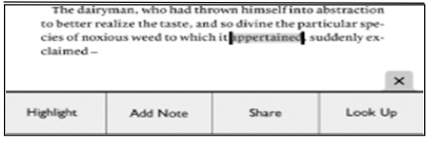

Q7. If I’m doing research and I want to highlight text or make a note about it, how do I do it?

A7. Press a word at the end or the beginning until it‘s highlighted, then drag the appropriate rod to the other end of the desired text. Tapping Add Note brings up the keyboard. Tapping Highlight appears to put underlines under the highlighted text. Tapping the highlighted text will also allow you to remove the highlight or add a note.
To see material that‘s been highlighted or notes made about, tap on text that‘s not highlighted; that brings up a Reading Tools Menu. Tap Content.

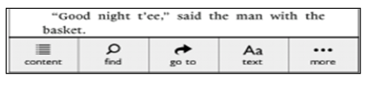

Q8. How do I make a bookmark?

A8. To place a bookmark on a page, tap in the upper right corner of the page and a dark bookmark will appear. To see the pages bookmarked, tap to open the Reading Tools Menu and tap Content.

Q9. How do I Find specific words in a book?

A10. Tap in the middle of the text, tap Find on the Reading Tools Menu, type the word you are looking for in the search box, and tap the Search button on the bottom row of the keyboard. Tap Close when finished.

Q10. How do I change the size of text and margins?

A10. On the Reading Tools Menu, tap on the text button. This opens a Text Dialog Box.

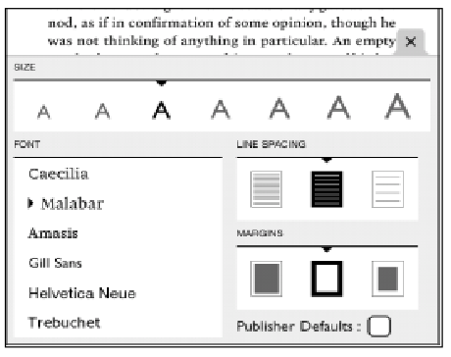

Tap on the A of the desired text size to make the change; tap on the desired line spacing, and the desired margin. There are also six font styles from which to choose. Just tap!

Q11. What is a Nook Friend, and how do I Invite someone to be my Nook Friend?

A11. A Nook Friend is a friend who has a B&N account, an email address in your contacts list, and has accepted your invitation to connect as a Nook Friend. Nook Friends can lend each other books and request books from each other for a loan of 14 days. A book can be loaned only once. This requires a Wi-Fi connection:
Press the Quick Nav bar, tap Settings, tap Social and set up each of the items below.

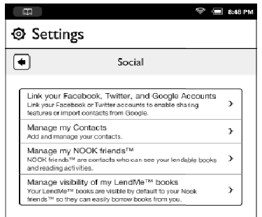

- To enable Sharing features, you must be Linked to B&N via either Google Gmail, Facebook, or Twitter. Tap on this feature and follow the prompts to sign in. Tap the Grant Access button.
- Tap on Manage my Contacts. Tap on the drop down arrow beside All Contacts and select Nook Friends. Tap Add Contact.

Tap in each box and fill in First Name, Last Name, and email address (doesn‘t have to be a Gmail address), then tap Invite as Nook Friend. Tap Save at the bottom of the keyboard. Tap Close.

If the friend‘s email is already in your contact list, just tap on the name and tap Invite. Tap Send. Tap Close.

- When your friend accepts the invitation, the name will be listed under Manage my Nook Friends. Tapping the name will show the books they can lend to you. Tap Details for info.

- Visibility of LendMe books is controlled by tapping the Show/Hide button.

Q12. What formats are compatible with the Nook?

A12. The Nook supports ePub and PDF formats for books and .jpg, .gif, and .png for screensavers.

You don‘t have to have a Nook to download books from B&N, you can download an app for your PC, laptop, or smartphone.

